Introducing wikis
Image: 'Application Mockup Pages'
www.flickr.com/photos/39897684@N00/39207474

“’Wiki wiki’ means quick in Hawaiian. A wiki is a website that can be quickly edited by visitors – creating a collaborative, organically developed, online resource”
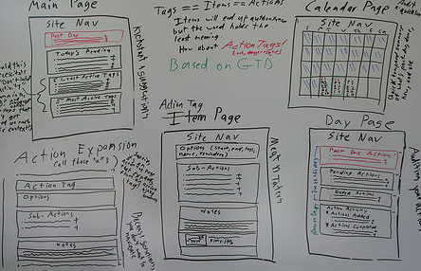
A wiki page is a bit like a whiteboard. All you need is a marker pen and you can change the content of the whiteboard. On a wiki page, just search for the edit link and you can change the page contents directly from your web browser.

Unlike a whiteboard, however, a wiki will store a history of page changes so you can see how a page has changed over time, and can bring back an old version if you want to.

A wiki website is build up of interlinked wiki pages. It is easy to create new pages.

Wiki pages are usually created in plain text with special ‘markup’ to indicate links and formatting.
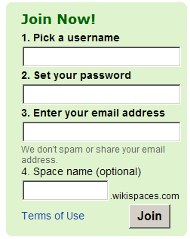
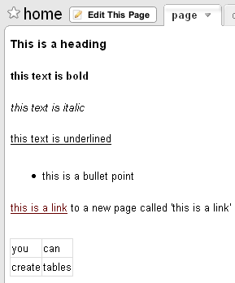
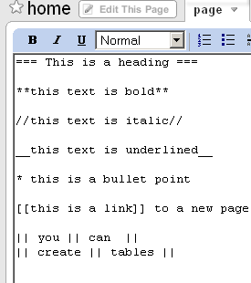
You can get your own free wiki from wikispaces.com or pbwiki.com. Just sign up and start using it.

You might use a wiki to share information, to draft a document, to organize an event or to collaborate with team members across the world.
Getting started: Wikipedia

Probably the best known example of a wiki is Wikipedia – a collaborative encyclopedia covering a wealth of topics.

- Visit www.wikipedia.com in your language and use the search feature to find an article of interest to you.
- If you think you can add something to this page (perhaps just by suggesting a new reference or tidying up the information that is already there) then click the ‘edit this page’ link at the top of the screen. (If you don’t think you can add anything, find another article.)

- Update the page text taking care to keep the special wiki markup intact. To make a word into a link to another Wikipedia entry, place the word in [[double square brackets]].
- You can view a preview of your changes, and when you are happy with them, save the page.
- The changes you have made are instantly available for the benefit of other wikipedia users.
- You can see the changes other have made (and revert the page to an older version) using the ‘history’ link at the top of the page.

Wiki markup makes it easy to create formatted pages

