Youth clubs | Yoga | Trips
Trampolining | Theme park trips | Thai boxing
Team building exercises | Swimming (women only sessions) | Swimming
Some languages | Skiing | Running
Rugby | Rock climbing | Quad biking
Pool | Outdoor adventure | Music
Motor biking | Martial arts | Kick-boxing
Ice-skating | Hockey | 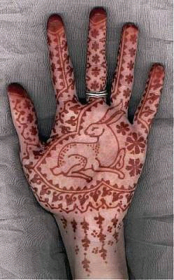  Henna painting
Hair and beauty | Go-karting | Girls groups
Free gym for women only | 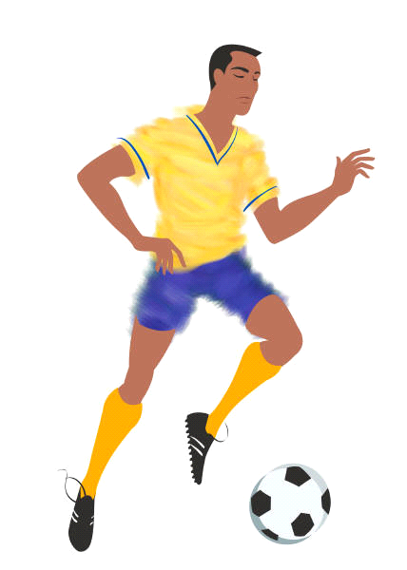  Football | Fitness clubs
Fashion shows | Driving lessons | Drama
Dance classes | Cultural things | Cricket
Creative things - art and craft | Computers | Cinema
Chill out clubs | Childcare | Boys groups
Bowling | Beauty therapy | Basketball
Athletics | Arts projects | Add your own ideas for activities
Add your own ideas for activities | Add your own ideas for activities | Add your own ideas for activities
Add your own ideas for activities | Add your own ideas for activities | Add your own ideas for activities
Add your own ideas for activities | Add your own ideas for activities | Add your own ideas for activities
Add your own ideas for activities | Add your own ideas for activities | Add your own ideas for activities

