Online videos
Practical Participation offer training & consultancy in using social media tools and strategies in participation projects.
This series of Getting Started guides are designed to offer a flavour of the tools available.
Using MotionBox (www.motionbox.com)
Version 1 - November 2007

Video is a powerful tool for storytelling and sharing information.

Online video editing tools let you create, edit and share videos easily without needing any special tools.

You can capture video footage on your digital camera or mobile phone or with a digital video camera.

Getting started: upload and edit videos

1) Visit http://www.motionbox.com and sign up for an account.

2) Look for the ‘upload videos’ link. A new window will open. Select the video files on your computer and choose ‘start upload’. (Remember to check the privacy settings for your videos)

3) It can take up to an hour for your videos to upload and become available to edit. When they are available you will find them in the
‘My MotionBox’ menu.

4) Select the videos you want
to edit together and choose
‘Add to Mixer’

5) Go to the mixer to edit your video. You can arrange your clips in the order you would like, and trim clips by dragging the ‘<’ handles.

6) When you have arranged your clips
as you want, you can save your new
video. You can make it public to
share your video with others.

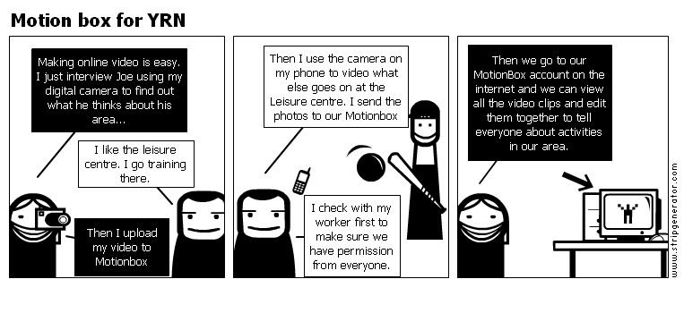
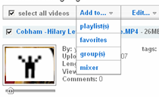

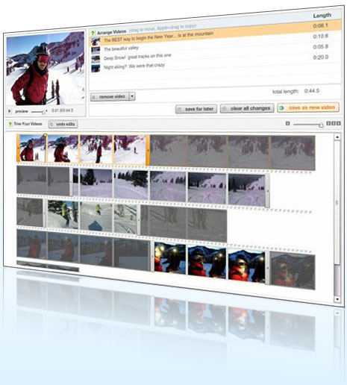
Important things to think about
Make sure you have permission from everyone in a video before you upload it to a video editing or sharing website. You should explain how you plan to use video clips you gather.
You may need permission from a parent or guardian of anyone under 16.

