Sharing stories
Version 1 – November 2007
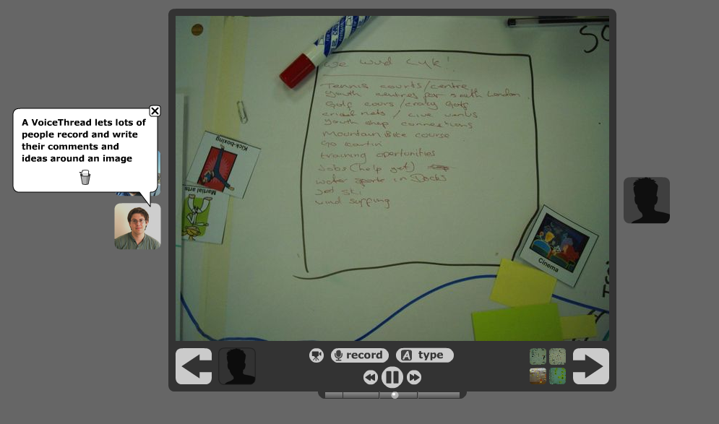
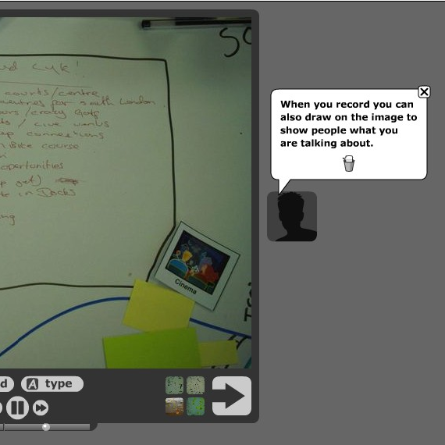
With VoiceThread (www.voicethread.com)
VoiceThread lets you tell the story behind your pictures.

You can record individual audio comments, and text notes on a picture. You can also create animated hand-drawn notes.

VoiceThread lets other explore a slide show of your pictures whilst listening to and reading your comments and descriptions of them.

You can use VoiceThread to share a story, to collect views from a group, or to create a record of your group discussions on a particular topic
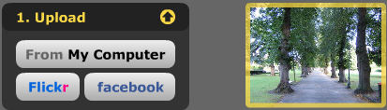
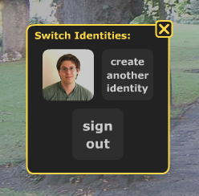
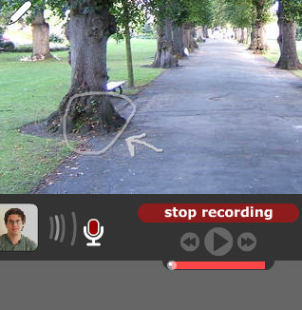
Getting started

1) Visit www.voicethread.com and register for an account or sign in.

2) Select ‘Create’ from the menu at the top of the screen.

3) Upload pictures that you would like to include in your slide show (or you can import pictures from a Flickr account). Wait for your photos to import or upload.

4) Select ‘Comment’ to bring up a slide show of your pictures ready for you to add your comments. Select ‘record’ to add an audio comment to this picture. Click stop recording when you are done. You can add text comments as well using the ‘type’ button.

5) Click the picture of a person in the bottom-left hand corner to change who is speaking. You can add new people to your group by selecting ‘Create new identity’. You can upload a photo of each group member.

6) When everyone has added their comments to this picture, you can move on to the next in your slide show.
Doing more with VoiceThread

You can publish your VoiceThread on a blog or MySpace page.

You can share your VoiceThread with others.

You can optionally allow others to record their comments on your VoiceThread (moderated by you first).

