Twitter
For the YOMO Practical Ideas for Participation event

“It’s not at many events that you are asked to make sure you keep your phones on.”
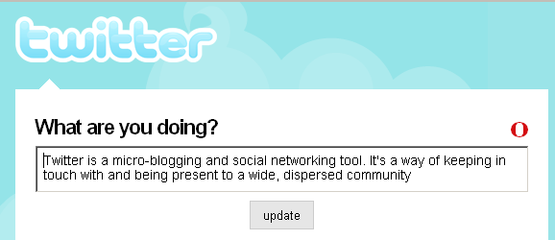
Twitter at Practical Ideas for Participation

We will be using twitter to:
- Provide you with updates
throughout the event.
- Create a space for shared
feedback and reflections.
Watch out for the ‘twitter wall’ showing all the most recent ‘tweets’ from delegates


With twitter you can:
- Send updates on what you’re currently doing, share your reflections on something you’ve just experienced, pose questions to other twitter users or just muse aloud.
- Follow the updates of others who use twitter.
- Allow other twitter users to follow your updates and so see what you are sharing.

- Access twitter from the web, from an instant messenger, from your computer desktop, from your phone or by SMS.

Twitter is a platform which can be used in many different ways.
Getting Started

1) Sign up by mobile phone
- Text ‘follow yomo07’ to 07624 801 423
- Follow the instructions that arrive by return text to create your account name.
- You will now be signed up to twitter, and you will receive updates from ‘Yomo07’ – the twitter account throughout the event.
- Save 07624 801 423 in your phone as ‘twitter’.

2) Sending your own updates
Send a text of 140 characters or less to twitter (07624 801 423) and it should automatically appear on the twitter wall.

Send us your thoughts, questions, reflections and more...

3) Follow someone’s updates
Text ‘follow username’ to get a message every-time ‘username’ sends an update. (E.g. ‘follow timdavies’ to track updates from Practical Participation)

Follow event delegates you want to keep in touch with.

4) After the event
Visit http://www.twitter.com to find out more and web-enable your account.

Text ‘off’ to twitter to stop updates coming to your phone after the event.

You can then keep tracking twitter via the web, instead of always via your phone.
Twitter tips:
If you want to use twitter after the event:

To get the most out of twitter check it regularly, either by phone or web.

Think of twitter as a virtual canteen. A space to catch up with people located across the country. A space to ask questions. A space to be present to colleagues and contacts.

If you want to respond to a question someone else has asked, prefix your message with @username (e.g. @timdavies) so that others know who you are replying to.

