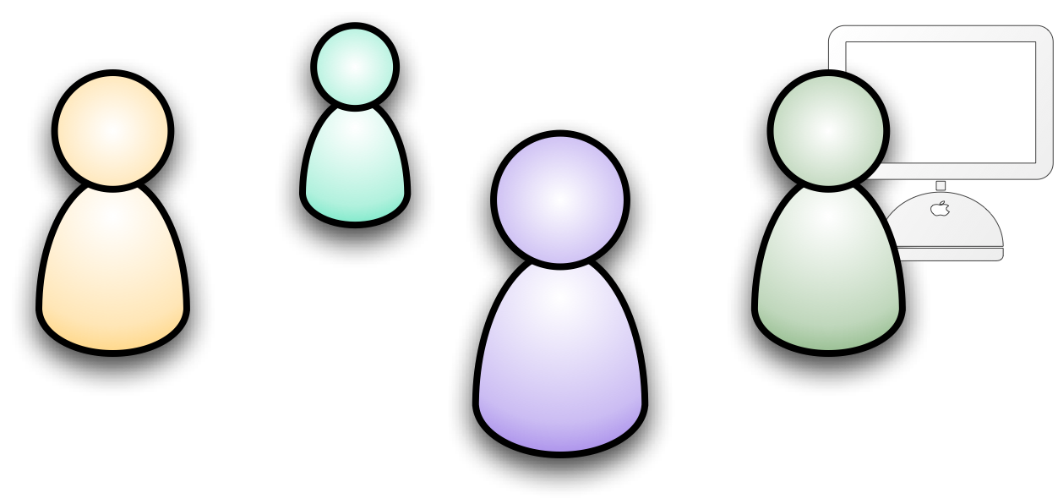
Youth Projects
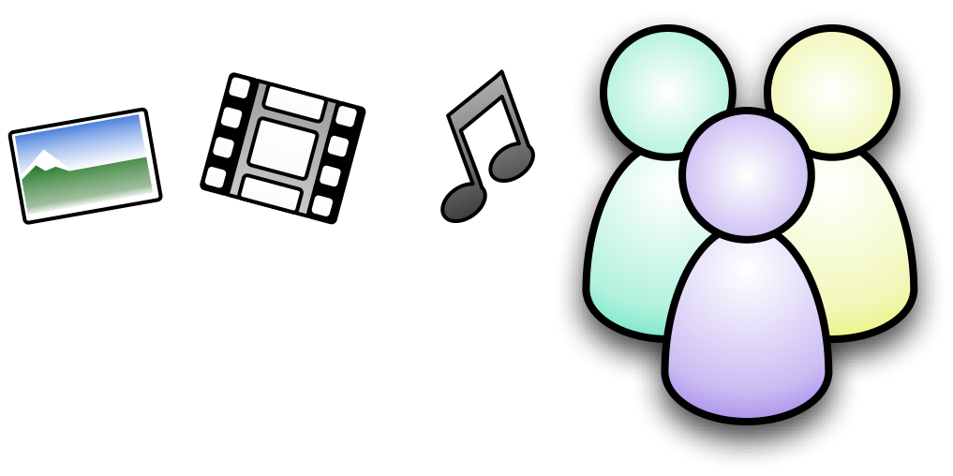

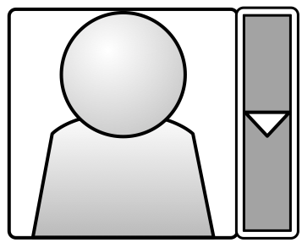
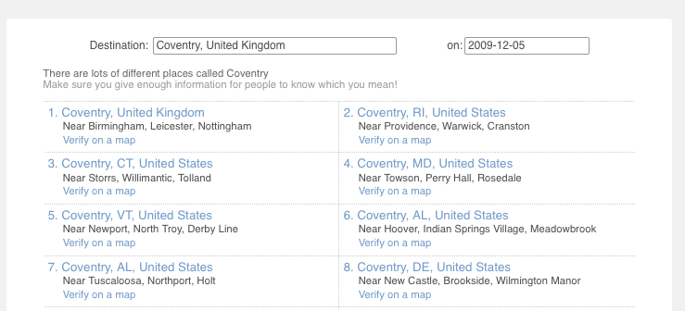


You can do amazing things with the Internet and social media. With the Internet you can reach new people locally and globally; you can publish information about your project cheaply and quickly; you can network with people; and a whole lot more.

As you use your new found online social media skills, there are a few things you need to think about to stay safe and to be effective on the web.
Think about each other

Have you got permission from people before you put photos or videos of them online?

Have you got a group agreement about who can put things online for the group?

Are you looking out for each other – and ready to support each other if any issues come up from your online project.
Think about your intended audience
What sort of media is best to reach the people you want to reach? Video? Audio? Photos? Text? Maps?

Think about how you will combine different media. Think as well about accessibility. Will you choice of media exclude anyone – and how can you make sure you provide alternative ways of get your information.
Think about identity
Do you want to link your content back to you as individuals? What information do you want to share about yourselves? Can someone find their way from the content you post to any private information about you? (For example, following the links on a social network site like Facebook or Bebo)
Once you put information online it is hard to remove it – and it could be found by anyone searching the web in future. Will this content reflect positively on you in future?
Think about interactivity

Are you planning to connect with and interact with people online? How will you manage comments and feedback on your media? Will you moderate comments and who will keep a check on them.

Are you being careful about your personal information when you interact online? If anyone contacts you and they are aggressive, or say unsuitable things, do you have someone you can talk to about this?
Think about impact
How will people find you? Have you mentioned key search words when you publish content (dates, locations, topics)?

How are you linking your online work with your offline project?

