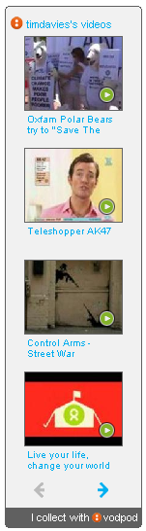
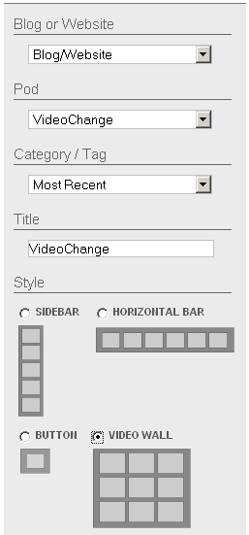
_ Video collecting? Vod Pod? _

Sites like YouTube allow you to flag videos as favourites – but your favourite list is limited to that website, and people have to visit that website to see it.

VodPod is a tool for collecting your favourite videos, or videos you want to share with others, from right across the web.

You can then display your favourite videos on your website, blog or online profile – and you can organise these clips into different sets (pods) or you can use tags to categorise them.

It’s a great way to help great videos to get a wider audience, to curate a collection of videos on a set topic, or to get fresh content for your web site or blog.
_ GETTING STARTED _

1/ Visit www.vodpod.com

2/ Following ‘Sign Up Now’ link to create an account

3/ Once you have completed the quick sign-up, look for the link to ‘get the share video button’

(if you are on a company PC you will probably need to use the ‘bookmarklet’)

4/ From your VodPod home page you can ‘Create a new Pod’ to collect Video Change clips.

5/ Go to any popular video sharing website and click the Save to VodPod button or bookmarklet you set up in 3/.

6/ Enter a description of the clip you’re sharing and use keyword tags to make your videos easy to sort in future.
_ YOUR VODPOD WIDGET _

Once you have collected your videos you can share them using a Vod Pod widget.

Look for the Widget option when you are logged in to VodPod.com and follow the instructions to get embed code for your Video Change pod.

You can paste the embed code into your profile or discussion spaces on the Video Change course website.
Week 2 Challenge:

Use Vod Pod to collect at least 5 videos that you think are effective at communicating a message.

Create a Vod Pod widget and paste your widget into the course discussion at www.videochange.org.uk/forum

Share your thoughts about what makes an effective and engaging online video.

