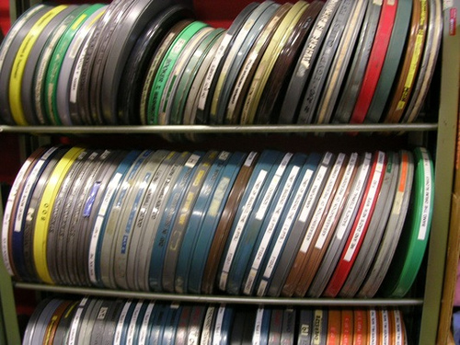
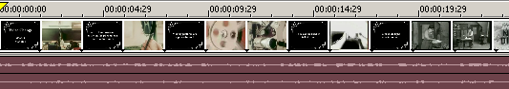
Stock footage and public domain clips

Engaging online videos often cut between different clips at a rapid rate. It is not uncommon to be shown 10 or 15 different ‘scenes’ in one minute of video.

Instead of going out to film all the different clips you might need (many of which you might only use 2 or 3 seconds of), you can use a public domain or stock footage resource.

Public domain footage, or footage under permissive copyright licences like ‘creative commons’ can usually be used for free in clips that you create.

With royalty free stock footage you may pay once to get hold of the clips, but you do not have to pay royalties every time you use them.
Five stock footage resources

1) The Internet Archive:
http://www.archive.org/details/movies
The Internet Archive host 100s of public domain and out-of-copyright films and clips for you to search, download and use.
2) US National Archives: http://video.google.com/nara.html
Clips from the US Government and NASA, including lots of old newsreel footage.

3) VJVault.com
http://www.vjvault.com
VJ clip libraries are great places to find very short, often impressionistic, clips to use.

4) Blip.tv
http://spinxpress.com/getmedia
Blip.tv is a video sharing site which allows creative commons video to be shared. SpinXPress offers a search interface making it easier to find video content from blip.tv.

5) Flickr.com Creative Commons
http://www.flickr.com
In the advanced search options you can find creative commons videos and photos.
Videos are in flash format, so you’ll need a tool like TubeTV (mac) or AnyVideoConverter (PC) to download them.
Credits and Copyright
You should always pay careful attention to the copyright licence on content. And think carefully about the licence you will then have to use for your video. For example, if you use a clip that can only be used in non-commercial contexts, you’ll have to apply a similar condition to your own video.
Getting Started
- Think creatively about the sort of clips you need. The exact image you have in mind may not be available, so you need to be flexible;
- Go to one of the websites listed below and search on key words to help you find suitable clips;
- View any possible clips. Pay attention to any copyright conditions or terms of use;
- Download the clips that you think you can use;
- Make a note of the source of any clips you download – you’ll need to add this to your credits on your clip.
- Import the clips into your editing software and splice them into the mix;
- Make sure you add credits to the end of your film to acknowledge the creators of any clips you have used.
Echo Park Film Center by Markschoneveld http://www.flickr.com/photos/51683598@N00/258477446

