E-mail lists
“Before we used a google group e-mail list it was really hard to keep track of who messages should be sent to and new members of our group were always getting missed out. Our google group also gives us an archive of e-mail that we can check back on.”

With Google Groups
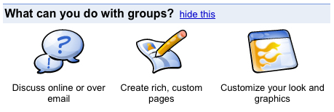
Getting Started

Creating a new group
1) Visit http://groups.google.com and look for the link to

2) Sign in, or create a Google Account if you need to.

3) Give your group a name, a description and choose the e-mail address it should use. Also choose whether it will be a 'public', 'private' or 'announcement only' (anyone can subscribe, only you can post messages) group.

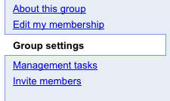4) Invite or add members to join your group. Make sure you have permission from anyone you plan to add to the group directly.

5) Once your group has been set-up, check out the group settings to customise it's appearance and, under 'e-mail delivery' options, to set the message that is added into the footer of every message sent via your list.

Running your group
Good e-mail lists require some facilitation. Exactly what is needed will depend on what your google group e-mail list is being used for, and how familiar the members are with using an e-mail list. You might need to think about:
- Keeping the members list up to date, helping new members join the group e-mail list, and explaining the list to new group members.
- Regularly posting new content to the list to stimulate discussion;
- Reminding group members to send to the list address if they revert to sending 'CC' e-mails instead.


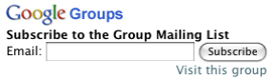
Google Groups is a tool for running your own e-mail discussion lists.

With an e-mail discussion list, members of the list can send a message to a one e-mail address (yourgroup@googlegroups.com) and all the members of the list will receive it.

Google groups also keeps a message archive so that group members can go back to check previous messages, building a repository of shared knowledge.

You can have open lists - which anyone can view and join. Or closed lists which are only accessible to the members you approve.
Using our e-mail list
To send a message to other members of the _______________________ group, address your e-mail to _______________@googlegroups.com.
Extra tips:
- If your e-mail bounces back, check that you sent it from the same address which you receive group messages to.
- You can change your settings for the list, including choosing to receive a daily digest of discussions, rather than individual e-mails, by visiting http://groups.google.com/group/________________
- At this address you can also find and search past messages.

Reminder cards: you might find it useful to give members of your list a card to keep by their computer - to remind them of the list e-mail address and details.
Tip: you can get a subscription box to place on your website - making it easy for new members to join your group. Look in the 'Group Settings' menu when you are logged in and on your group's page.

RSS: Google groups output an RSS feed of the most recent messages and most recent discussion topics.
You can use this to place a list of recent discussions seamlessly on your main website, or to keep track of discussions in an RSS reader or personal dashboard such as NetVibes.

