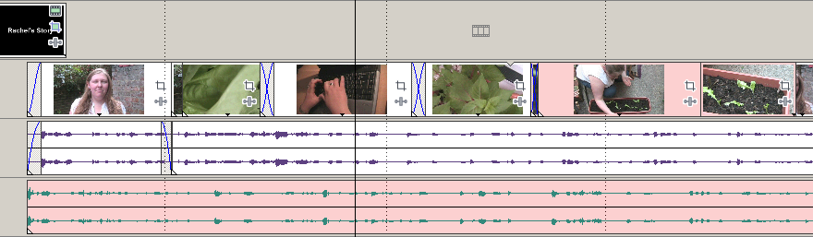
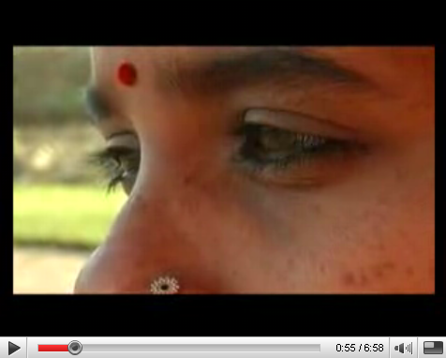

As obvious as it sounds, climate change affects everybody.
But climate change is already having a disproportionate impact on people in developing countries, and it’s hitting women hardest.
In some places, people are fighting back and women are leading the way. Like in Bangladesh, where women in poor communities are leading projects to raise homes and introduce early warning systems to help cope with increasingly severe floods.
But to tackle climate change on a global scale we all must play our part by changing our own lives and encouraging our friends and families – and the politicians who act in our names – to make a difference too.
We’re all in this together. We must all be part of the solution.

Your challenge

The Sisters on the Planet videos at http://www.oxfam.org.uk/sisters explain how women are affected by climate change – and how women can lead the way in the right against it.

Watch the Sisters on the Planet videos and then create your own short video to tell the story of a ‘Sister’ in your community. Someone who is taking action in the right against climate change and climate poverty.

Your video could be about an everyday action, such as trying to reduce car travel or to use less of plastic bags, through to big campaigning actions like lobbying the local authority to improve public transport. Your clip should help show that there is a real movement of people taking simple actions to make a big difference.
Creating a ‘Sisters on the Planet’ video
You can be creative in the video you create, but the ‘recipe’ below may help you get started:

- Find your Sister on the Planet – choose someone (man or woman) who is taking action on climate change.
- Interview your Sister on the Planet on camera – choose a good backdrop and someone where you can get good audio. You could ask: What action have they taken? Why did they take it? What impact does it have? What have they learnt?
- Shoot some ‘B-Roll’ and extra footage – gather clips that help tell the story: different camera angles, images of the person taking their action etc.
- Edit the interview – to cut out any bits that you don’t want in your final clip, or to re-order any parts to help tell the story. Layer your extra footage on top of the interview to add interest and add titles to replace your voice from the interview.
Add titles to replace your voice in the interview
Separate the interview soundtrack from the images
Layer on relevant extra footage to tell the story.
Add a music track to add a sense of atmosphere to your clip.

