
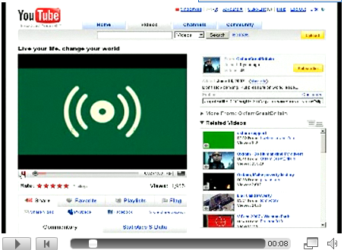
ONLINE VIDEO: STEP BY STEP .

Getting a video onto the internet is easier than ever. Website like YouTube.com let you record to their sites straight from your webcam. However, creating a really effective online video requires just a little bit of forward planning. You need to know the message you want to share – and to think about how you will get in across.

This guide takes you through six steps to effective online video…

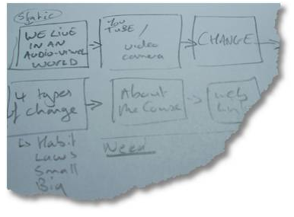
Create a story board
Even if you’re creating a very short video, or recording a monologue on web cam – think about the message you want to get across and the different ways you can communicate it. Write down the key points you want to make – and then think about whether you will communicate them with a voiceover, a talking head, an interview, using still images or stock footage, or using text on screen.
3 VIDEO STYLES | Direct to web-cam:   | What are you key messages?  How will you keep your clip short and interesting? | Words and pictures:  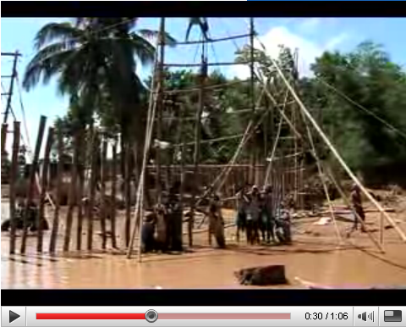 | What images help tell the story you are sharing?  Will you use a voiceover or text on screen? | Interview on camera:  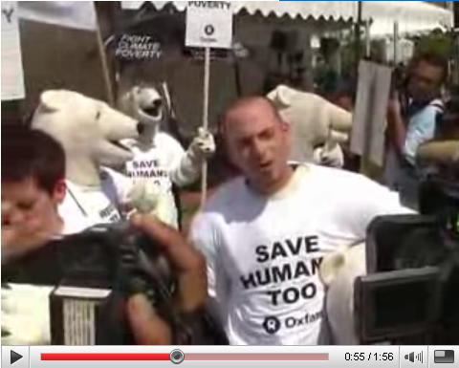 | What questions will you ask?  Do you need extra clips to give context to your questions?


Find the footage
Once you know the different parts of your video it’s time to gather together the video and images that you might use in it.
Film it  Put together a list of the clips you want to capture and head out with your camera. If you plan to use the audio from your clips (e.g. on an interview) make sure the sound is good quality. When you are filming people, think about capturing a few ‘context setting’ clips of the surroundings that you could use to liven up an edit. | Find stock footage  Whilst you can’t just use any clip you like from other videos – there are a number of online resources offering videos you can use and adapt. Archive.org includes many full videos licensed under ‘Creative Commons’ and VJVault.com offers many short clips. Or you can search for ‘stock footage’ to buy online. Make sure you add credits to your video for any stock footage you use. | Using photos  Not every image in your video has to be a moving one – and you can use transitions and effects to add motion to photos in any case (e.g. zooming in on particular areas of an image). Check out your photo collection, or search for ‘Creative Commons’ images you can use on photo-sharing sites like Flickr.com



Transfer and convert
Once you have collected all the resources you will use in your
Video you need to transfer them all to your computer in one place.

You may need to change the file format of your clips before you can use them in your video editing software. Check which formats your editing software can open and if you need to you can use a video format converter like the free version of Any Video Converter from http://www.any-video-converter.com

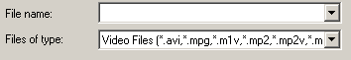


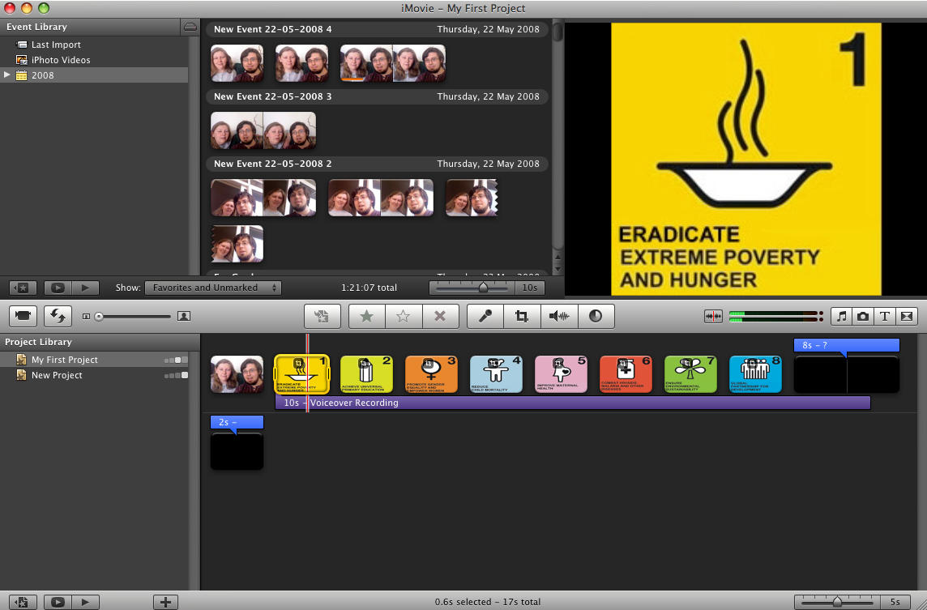
Edit your video
☑ Keep it short. Successful videos on the web are often less than three minutes long.

☑ Use special effects in moderation. Transitions and visual effects can really add to your clip – but be careful not to over-use them.
☑ Be creative. Think about the way your edit could use humour or strong visual images to communicate.

☑ Keep the file size small. When you use the ‘Render’ or ‘Make Movie’ option make sure the file you create is less than 100 megabytes.
_ TOP TIPS _

Use your video editing software of choice to put all your clips together, to add titles
and to add a soundtrack to your video. You should be able to split your clips into short
chunks that you can then put together as a dynamic edit. When you are done, you will need to ‘export’ or ‘render’ your video into a format like QuickTime (.mov), Windows Media (.wmv) or MPEG (.mpg) video ready to upload to the web.


Embed your video
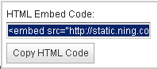
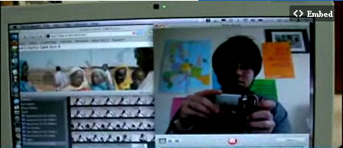
Upload your video
Video sharing services like
YouTube.com, Google Video and Blip.tv take your video file and convert it into a Flash Video so that others can view it direct online – without having to download it or use an extra video player.

For Week 1 of Video Change you can upload your video to the Video Change site itself. Look for the ‘Video’ tab, select and upload your file. The site will e-mail you when it has been converted.
Your video doesn’t just have to be seen
on the site where you uploaded it. You can embed your video on other websites, blogs and online profiles.

Look for the ‘Embed this video’ option and copy the code that is displayed. Paste this code onto your profile page, or anywhere which says it allows ‘widgets’, ‘embed code’ or full ‘HTML’.

