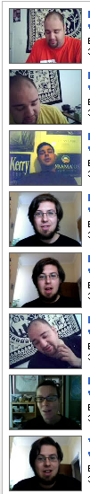
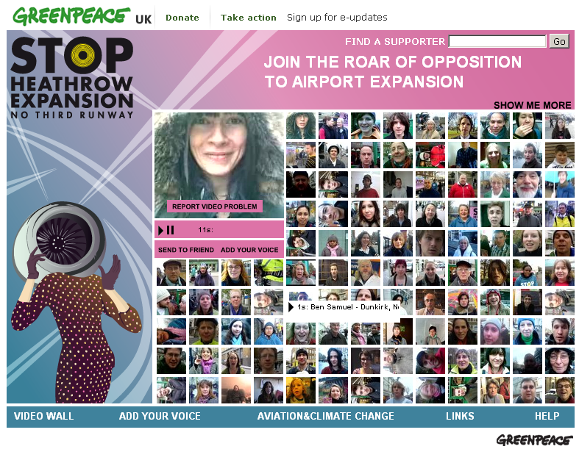
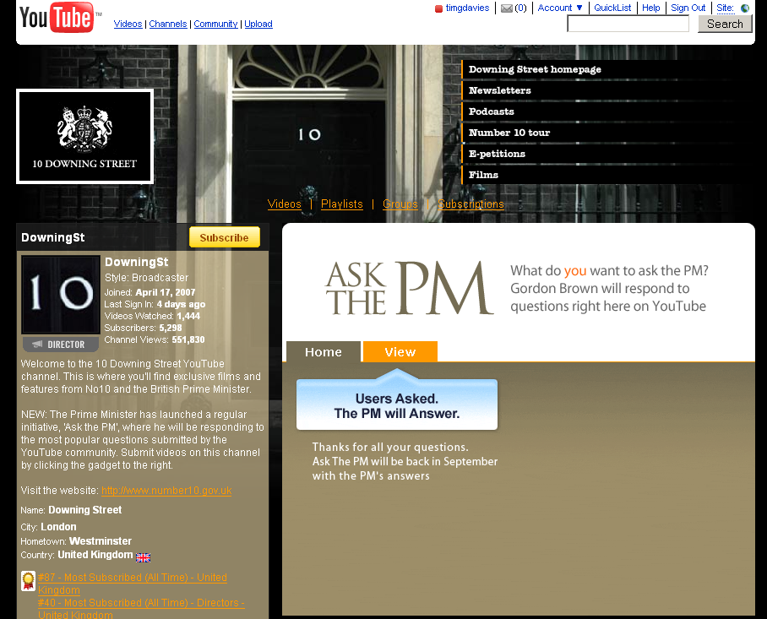
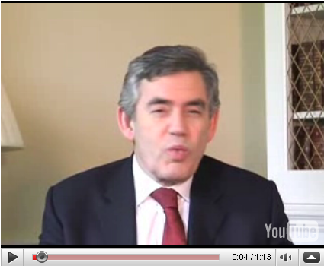
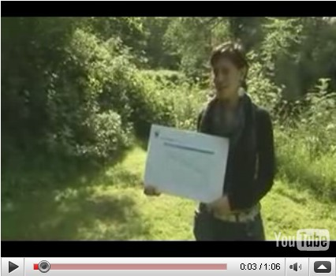
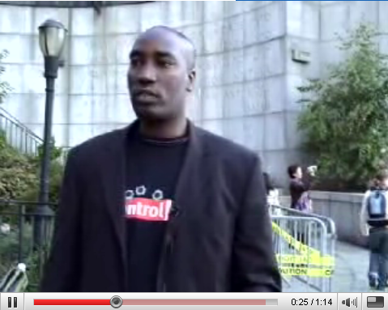
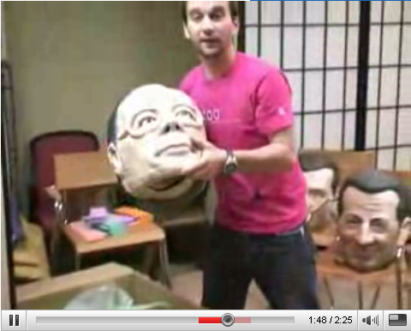
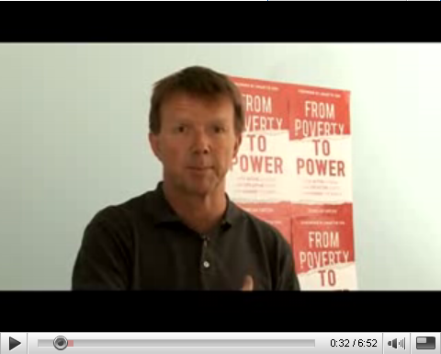
_Converse_
Use video conversation tools like http://seesmic.com to create a discussion around key campaign topics.

With Seesmic you create short video monologues to spark and reply to conversations.

Share the discussion thread to provide others with an insight into the issue.

_Participate_
Look out for opportunities like ‘Ask the PM’ on youtube.com/downingst to record your video messages and questions direct to decision makers.

Change campaigner Emma used ‘Ask the PM’ to get a direct public reply from Gordon Brown to her question on climate change.

_Petition_
Instead of collecting signatures, why not collect video messages to show the depth of support for an issue.

Greenpeace ran a large video petition using mobile phone video clips to protest against Heathrow Expansion. You could take petition clips on a phone or camera, and edit them together to show decision makers that people care, and to visually demonstrate that there is a real movement for change.

_Campaign_
Communicate a campaign message with an interview, an animation or a monologue to camera.

Video offers a way to explain the issues, motivate people and invite them to take action.

_Inform_
Use video to offer an in depth explanation of an issue.

You could record a talk, present a mini-lecture with visual aids, or create a ‘frequently asked questions’ clip.

_Report_
Take a video camera with you when campaigning and share an insight into what being a campaigner means

Like this reporting from the G8.
There are many ways you can use online video to make a difference. Take a look at the six approaches below.

